ROSSMANN STORES

FORECASTING CASE STUDY
  - SIX WEEKS AHEAD TIME SERIES ANALYSIS

- Introduction
1.1 Background of the Study
Forecasting is an important part of business planning because it helps businesses prepare for future demand and make better decisions. Operating without a reliable baseline for comparison is like driving at night without headlights, making it difficult to anticipate what lies ahead. For retail businesses, knowing how much they are likely to sell helps them manage inventory, schedule employees, and avoid having too much or too little stock. However, predicting sales is not always straightforward, as several factors, including promotions, holidays, customer behavior, and seasonal patterns, can influence daily sales.
This project focuses on Rossmann, a retail drugstore chain, using historical daily sales data from 1,115 stores over approximately two and a half years. For this study, we selected Store 800, which has 942 daily sales records, covering January 1, 2013, to July 31, 2015. Since sales can change from one day to another, understanding past trends and patterns is important when trying to predict future performance.
To better understand these patterns, the study involves cleaning and exploring the data, examining sales trends and seasonality, and applying time series techniques such as stationarity testing, ACF, and PACF. Different forecasting methods are also developed and compared with simple baseline models to see which approach provides more reliable predictions.
The goal of this project is to use historical sales data to develop a forecasting approach that can help Rossmann predict sales for the next six weeks and make better decisions about inventory, staffing, and daily store operations.

1.2 Statement of Problem
One of the challenges retail businesses face is accurately predicting future sales. Customer demand can change from day to day, making it difficult to determine how much inventory to maintain or how many employees will be needed. Inaccurate forecasts can contribute to stock shortages, excess inventory, increased operating costs, or inefficient use of resources.
In the case of Rossmann, store managers are responsible for preparing sales forecasts up to six weeks ahead. However, relying on individual judgment and different forecasting methods can lead to inconsistent results across stores. Without a common approach for measuring forecast accuracy, it becomes difficult to determine whether existing forecasting practices are reliable or whether improvements are needed.
The main problem addressed in this study is therefore how to use historical daily sales data to develop a consistent forecasting approach that can predict future sales while accounting for patterns such as seasonality, promotions, holidays, and store closures.

1.3 Aim and Objectives of the Study
The main aim of this study is to analyze historical sales data from Rossmann Store 800, consisting of 942 daily records, and develop a reliable approach to forecasting sales for the next six weeks.
To achieve this, the study focuses on preparing and exploring the data to understand sales patterns, trends, and seasonality. It also involves testing for stationarity, examining ACF and PACF plots, and developing forecasting models, including simple baseline methods and SARIMA. The models are then evaluated using MAE, RMSE, and rolling back testing to determine which approach performs better. Finally, the study provides a six-week sales forecast and recommendations on whether the proposed method would be practical for Rossmann to adopt and maintain.

2.0 Exploratory Data Analysis
The original dataset contains 1,017,209 records across nine columns. Store 800 was selected for individual analysis, providing 942 daily records spanning 1 January 2013 to 31 July 2015. We examined the Store 800's sales performance, data quality, distribution, operating patterns, promotions, and holidays to identify factors relevant to six-week sales forecasting.
The EDA of Store 800 identified variation in daily sales, differences across weekdays, higher average sales on promotional and school-holiday days, and a clear relationship between store closure and zero recorded sales. The investigation also showed that potential outliers should be examined in their business context before any removal or transformation.
These findings provide useful context for the next stage of the project. Time-series decomposition, baseline forecasting, and model evaluation will be addressed separately.

2.1 Data Quality and Repeated-Row Check
Store 800 contains 942 records across nine columns, covering 1 January 2013 to 31 July 2015. All nine columns have zero missing values. The date column was converted to datetime format, and StateHoliday values were standardized to resolve inconsistent representations of zero. The dataset contains 942 unique dates, with no repeated dates. Although some rows may have identical values across columns, identical values on different dates do not necessarily indicate duplicate records, particularly on store-closure days. Therefore, records were not removed solely because their values matched.

2.2 Sales Distribution and Outliers
Descriptive statistics for Store 800 showed average daily sales of 4,413.86, a median of 4,850, and a maximum of 12,368. A histogram and box plot were used to examine the distribution and identify potential outliers.
Figure 2.2.1 shows that daily sales are concentrated mainly between 3,000 and 7,000, alongside a large spike at zero that reflects store-closure days. The box plot identifies potential outliers, including zero-sales days and unusually high sales.

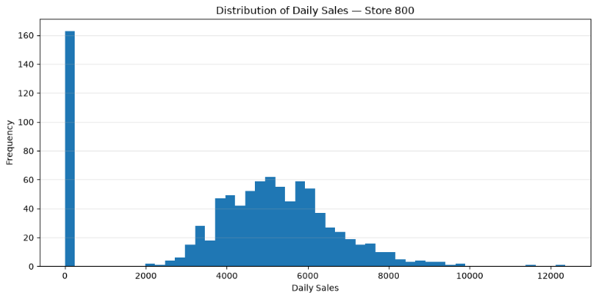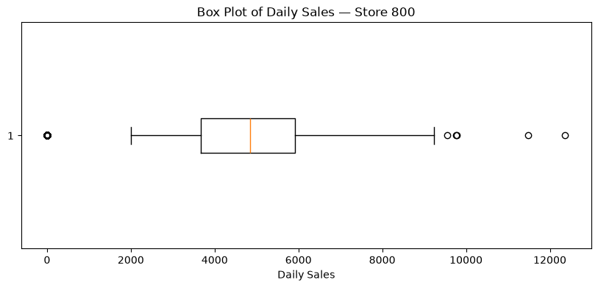
Figure 2.2.1: Store 800 – Distribution of Daily Sales and Identification of Potential Outliers (Histogram and Box Plot)
The IQR method identified 168 potential outliers: 163 low outliers and five high outliers. Investigation showed that all 163 low outliers corresponded to zero sales on days when the store was closed. The five high outliers occurred on open days, with four associated with promotions. These observations reflect business conditions and should be investigated rather than automatically removed before forecasting.

2.3 Store Operations and Promotion
The store operated on 82.7% of recorded days, generating total sales of 4,157,860. Closed days accounted for 17.3% of observations and recorded zero sales. Average recorded sales were zero on closed days and 5,337.43 on open days. This demonstrates the importance of considering operating status when interpreting sales and identifying outliers.
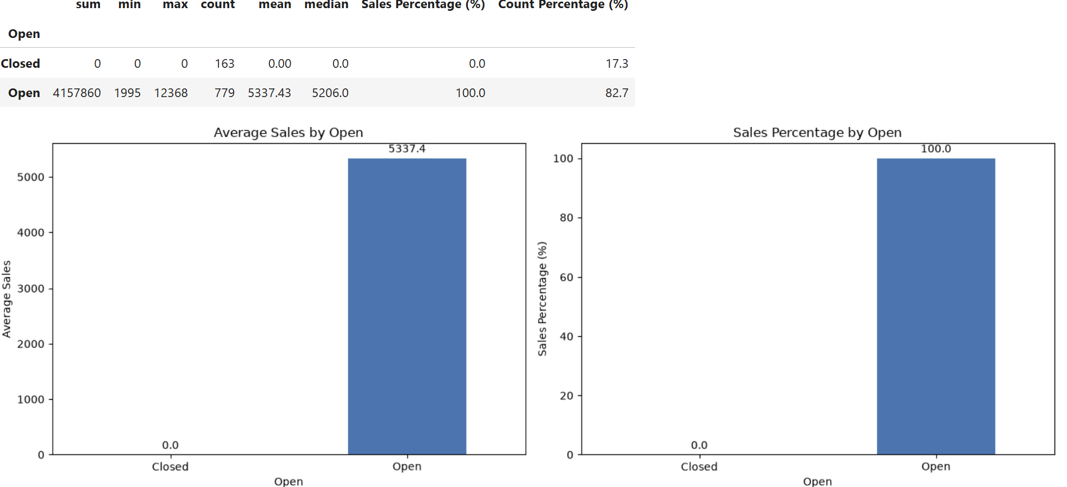
Figure 2.3.1: Store 800 – Sales Performance by Operating Status (Average Daily Sales and Percentage of Total Sales)
On all recorded days, average sales were 3,427.26 without promotions and 6,008.87 with promotions. Restricting the comparison to open days produced averages of 4,649.58 without promotions and 6,180.55 with promotions, a difference of approximately 32.9%. The data also indicated that the promotions occurred on 38.2% of recorded but contributed to 52.03% of total sales.
This suggests that promotional days are associated with higher average sales. However, the analysis does not establish that promotions caused the difference.

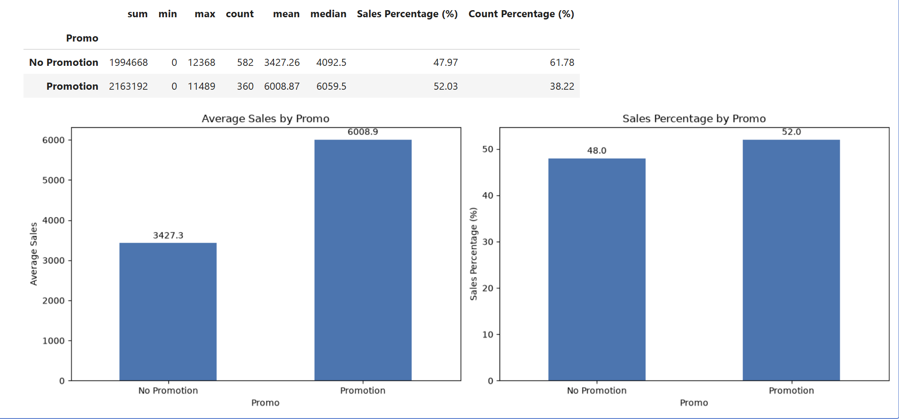
Figure 2.3.2: Store 800 – Sales Performance by Promotion (Average Daily Sales and Percentage of Total Sales)

2.4 State and School Holidays
After standardising the holiday categories, the analysis found average sales of 4,554.06 on days without a state holiday. Recorded average sales were zero for categories of Christmas, Easter and public holidays. These categories contained relatively few observations, and store closures may explain the zero averages. The results should therefore be interpreted cautiously.
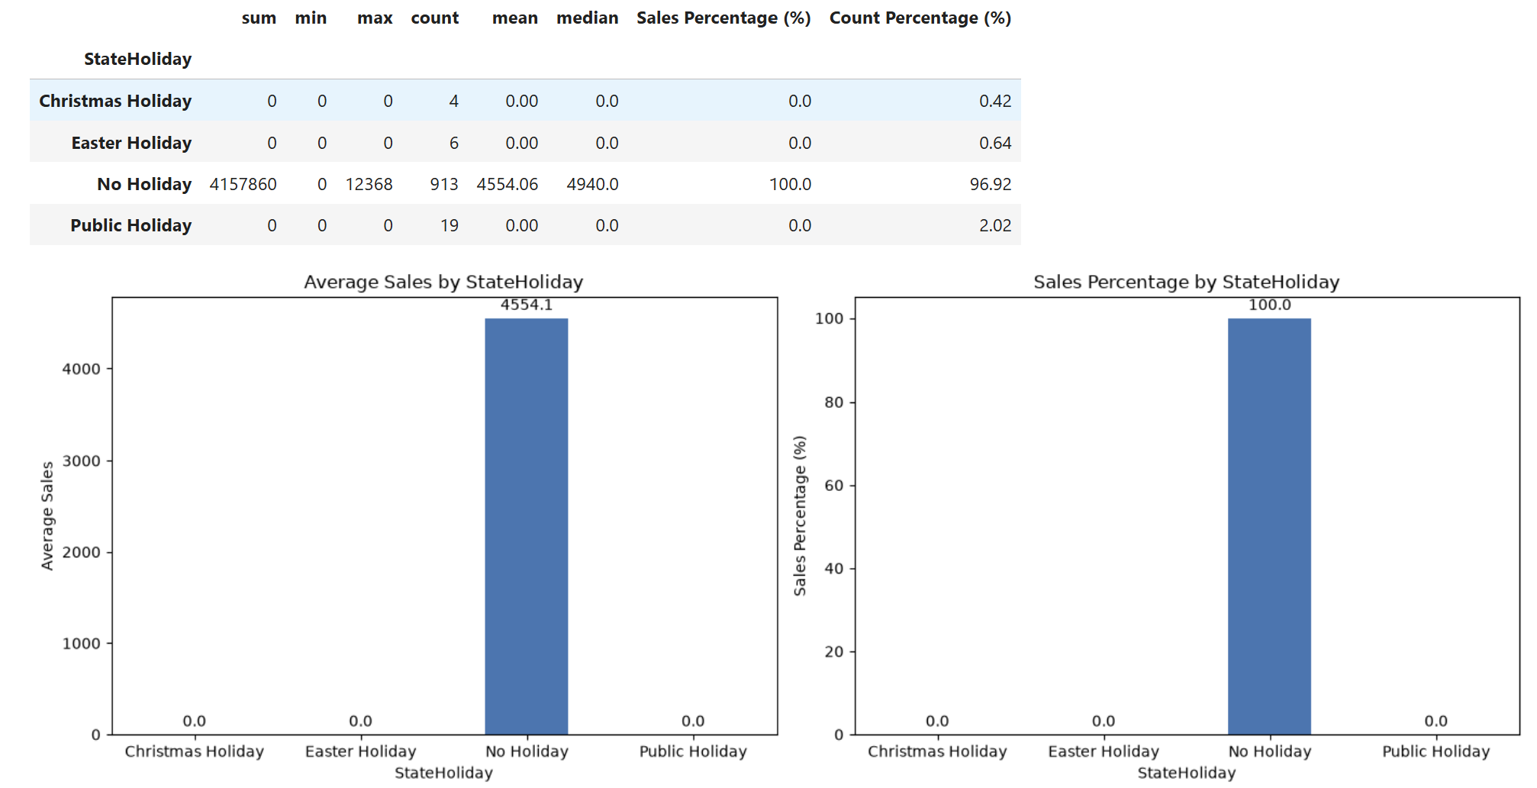
Figure 2.4.1: Store 800 – Sales Performance by State Holiday Status (Average Daily Sales and Percentage of Total Sales)

School holidays affected Store 800 on 150 days (15.92%), contributing 17.74% of total sales. Average recorded sales were 4,318.66 on days without a school holiday and 4,916.53 on school-holiday days. This represents an approximate difference of 13.8%. The result describes an observed association and does not establish causation.

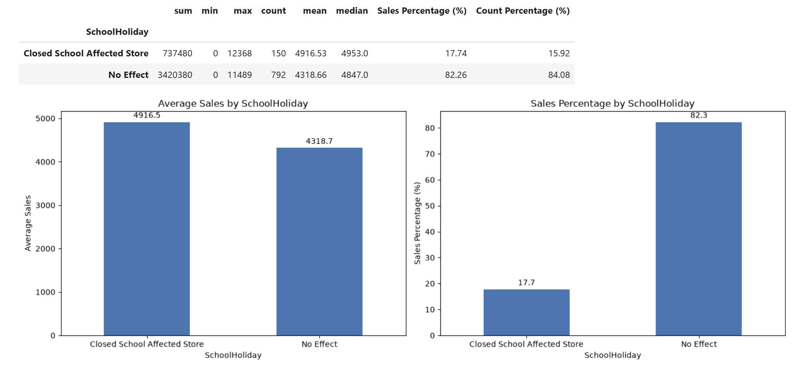
Figure 2.4.2: Store 800 – Sales Performance by Effect of School Holiday Status (Average Daily Sales and Percentage of Total Sales)

2.5 Weekly Sales Trend
From Figure 2.5.1, the average recorded sales varied by weekday. Monday had the highest average sales at 5,832.57 among the seven weekdays contributing 18.80% of total sales, while Sunday had an average of zero. The zero Sunday average is consistent with closure days in the dataset, although opening patterns should be considered when interpreting weekday comparisons.

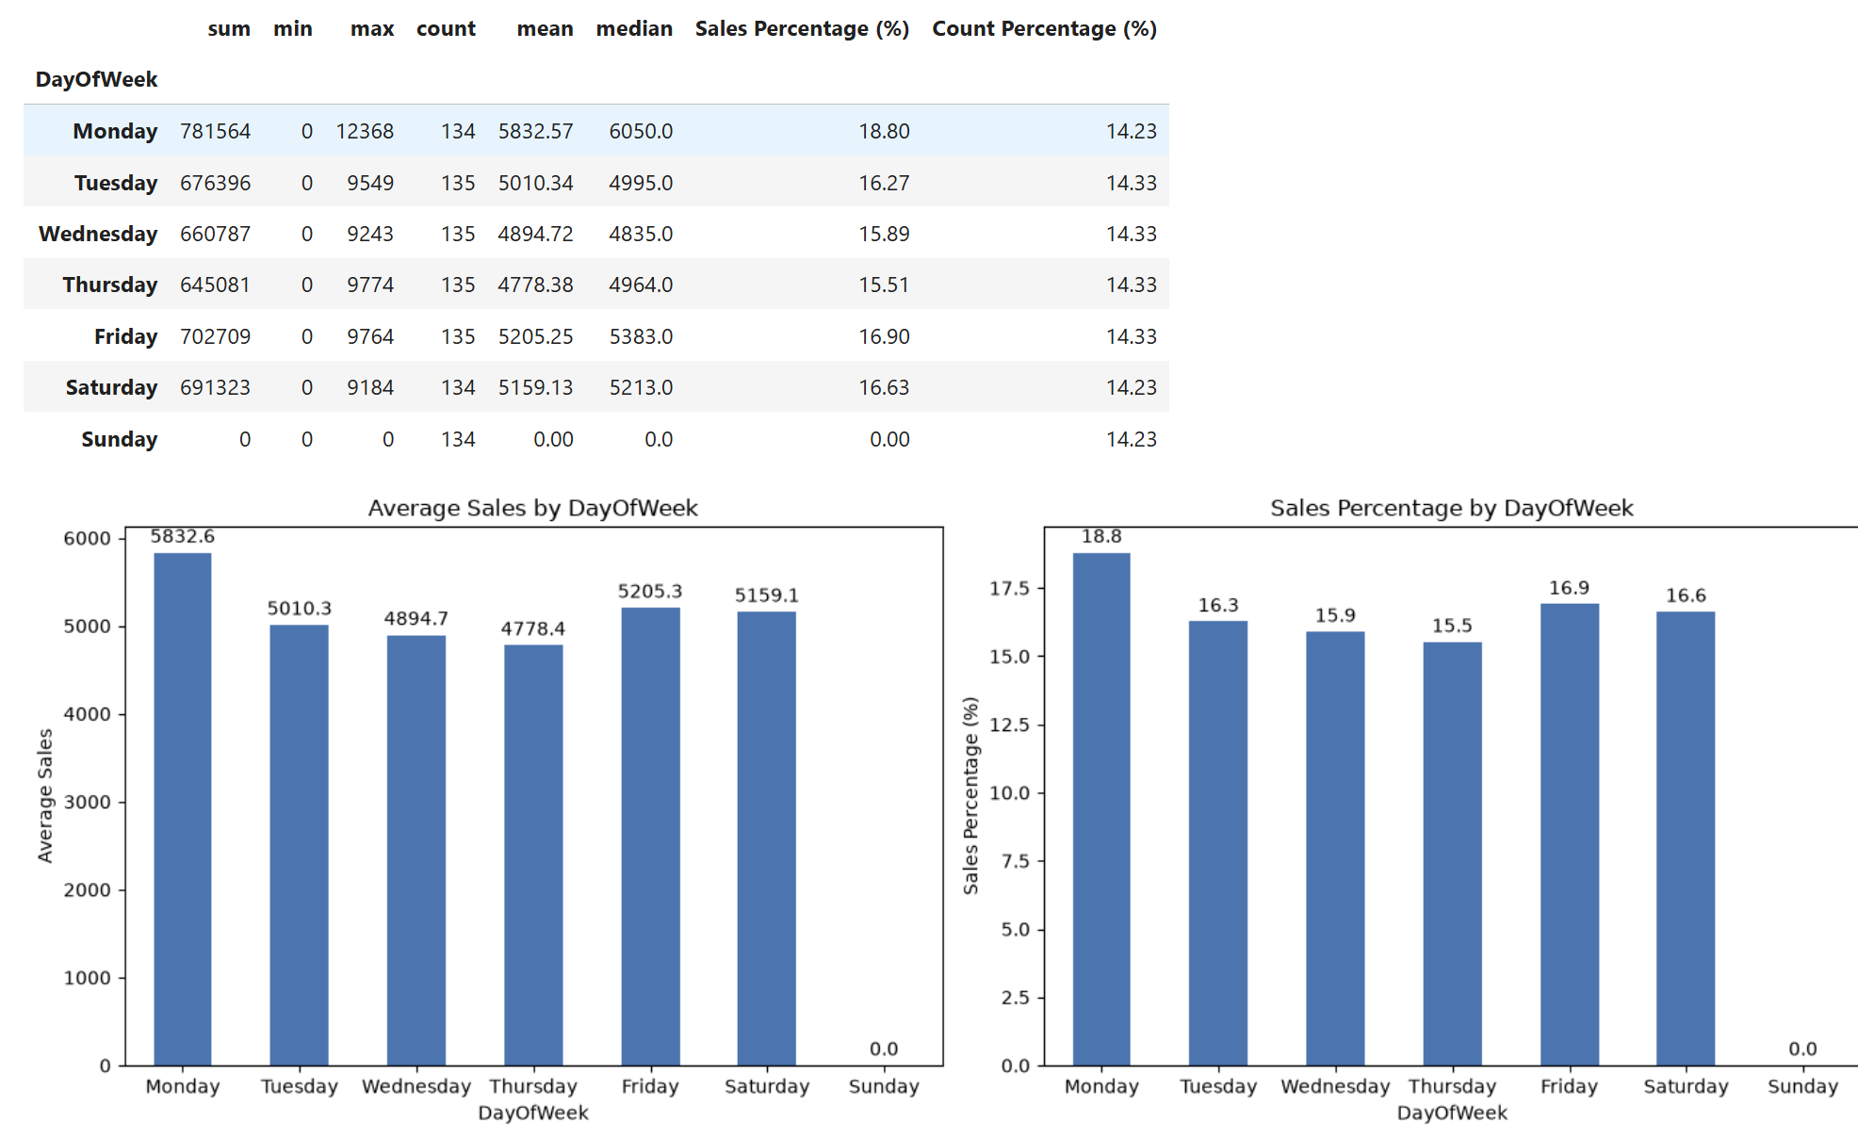
Figure 2.5.1: Store 800 – Sales Performance by Day of the Week (Average Daily Sales and Percentage of Total Sales).

Figure 2.5.1 shows a decline in average recorded sales from Monday through Thursday, when average sales were lowest at 4,778.38. Average sales then increased on Friday before easing slightly on Saturday.
The results suggest strong weekly seasonality, with higher sales at the beginning of the week and towards the weekend. Hence, this exploration suggests that the sales day should be considered an important variable in the six-week sales forecasting model.

2.6 Sales Patterns Over Time
In Figure 2.6.1, a line chart of daily sales showed repeated increases and decreases over the observation period. This indicates fluctuations in daily sales. Further decomposition and forecasting analysis will be conducted separately.
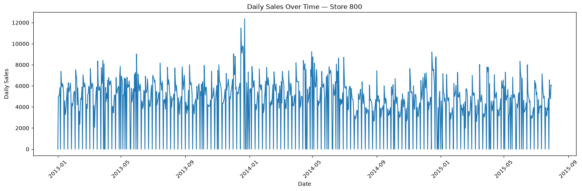
Figure 2.6.1: Store 800 – Daily Sales Trend Over Time (2013–2015)

  - Decomposition
To examine the underlying trend, recurring seasonal patterns, and unexplained fluctuations, an additive time-series decomposition was performed on Store 800's daily sales using a seven-day seasonal period.
Store 800's daily sales exhibit a recurring seven-day pattern. Sunday sales are consistently zero because the store is closed, making the day of the week an important factor in its sales behaviour. As shown in Figure 2.7.1, the trend component fluctuates throughout the study period, indicating that sales levels are not entirely constant over time. Therefore, a forecasting model based only on a fixed average may struggle to capture these changes.
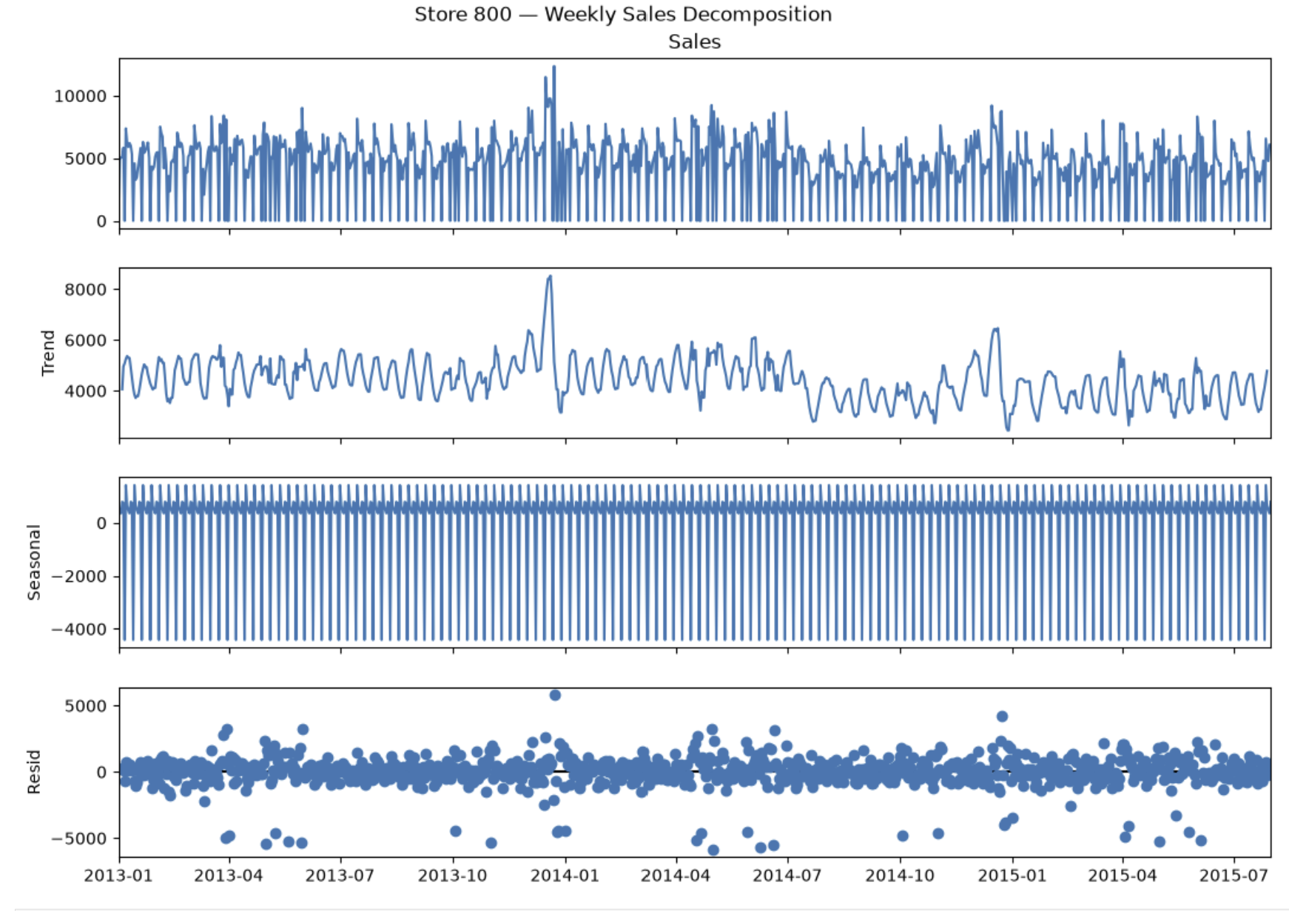
Figure 2.7.1: Store 800 – Weekly Decomposition of Daily Sales (2013–2015)

The residual component contains variation not explained by the estimated trend and weekly seasonal pattern. This indicates that other factors may also influence daily sales. Decomposition helps identify patterns in the series, but it does not establish the causes of changes in sales.
Hence, the decomposition identifies weekly seasonality alongside a changing trend and unexplained daily fluctuations.

3.0 Time Series Models Using Statistical Methods
3.1 Training and Testing Data
Before developing the forecasting models, Store 800's daily sales data was prepared for training and testing. The original Store 800 training dataset contained 900 daily sales observations, with the remaining 42 days reserved for evaluating the six-week forecast.
The Augmented Dickey–Fuller (ADF) test was applied to the 900-observation training series. It returned an ADF statistic of −3.7618 and a p-value of 0.003323. At the 5% significance level, we rejected the null hypothesis of a unit root. This provides evidence against a unit root for the tested series, although the ADF result alone does not establish that every aspect of the series is stationary.
First-order differencing was also examined, and the differenced series returned a smaller p-value. The original series already rejected the unit-root null in this ADF test, so the test result by itself did not require additional differencing. Differencing decisions were considered alongside the model-selection procedure and the subsequent forecast evaluation.
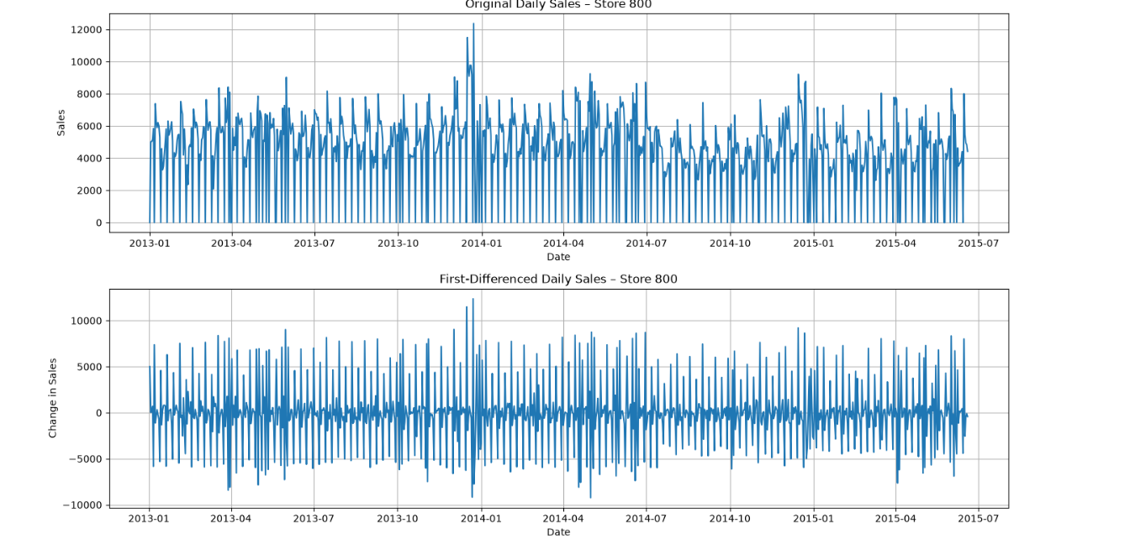
Figure 3.1.1: Comparison of Original and First-Differenced Daily Sales for Rossmann Store 800 (2013–2015).
The pmdarima differencing tests recommended no ordinary or seasonal differencing (d = 0, D = 0), while Auto ARIMA selected a model with one order of ordinary differencing (d = 1). These procedures use different criteria and need not produce identical recommendations. We retained the Auto ARIMA-selected model for evaluation and compared its out-of-sample performance with baseline methods rather than treating either test as conclusive on its own.

3.2 Additional Stationarity and Time Series Diagnostics
A second ADF result was recorded with a statistic of −3.6074 and a p-value of 0.0056, also below the 5% significance level. This result likewise rejects the unit-root null for the series tested. Because the report records two different ADF statistics and p-values, the exact series and settings used for this second test should be confirmed in the notebook before submission.
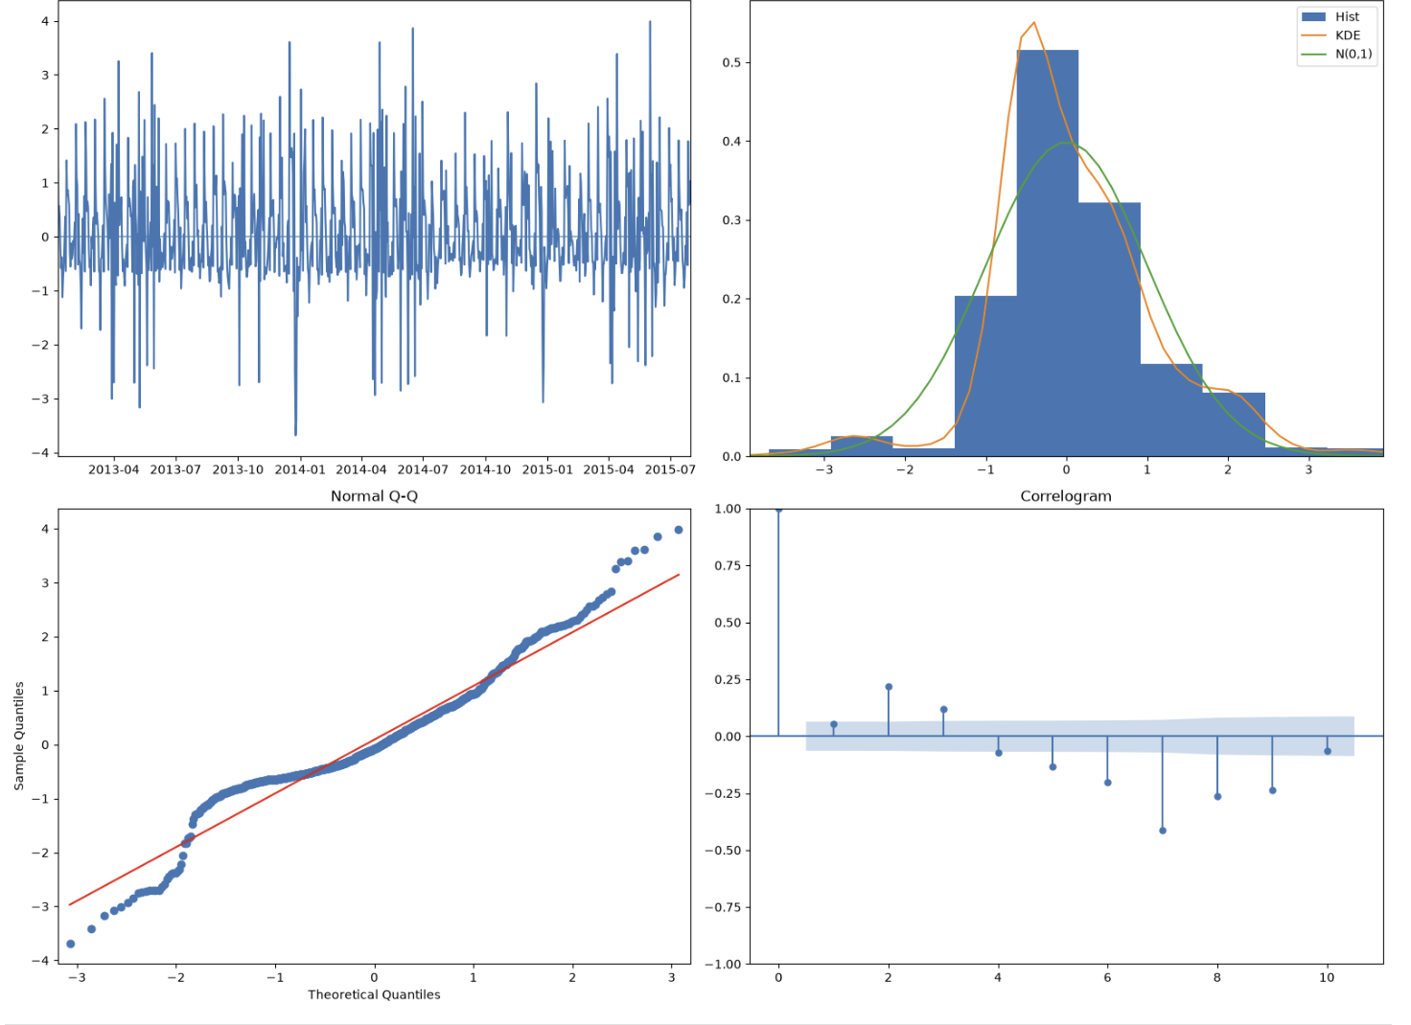
Figure 3.2.1: Time Series Diagnostic Plots for Store 800
The diagnostic plots were examined to assess the distribution and dependence structure of the series shown. The histogram and density plot indicate that observations are concentrated around the centre, while the Q–Q plot shows departures from normality, particularly in the tails.
Furthermore, the correlogram shows significant autocorrelation at several lags, suggesting that some time-dependent patterns remain in the plotted series.
Overall, the reported ADF tests provide evidence against a unit root in the tested series. The diagnostic plots also indicate non-normality and remaining autocorrelation in the plotted data. These findings should be interpreted according to whether each diagnostic was applied to the original series or to model residuals.

3.3 Autocorrelation (ACF) and Partial Autocorrelation Function (PACF) Analysis
The next phase was focused on identifying and training an appropriate forecasting model for Rossmann Store 800. The previous analysis revealed strong weekly seasonality and fluctuations in daily sales, suggesting that a model capable of capturing relationships between past observations and recurring seasonal patterns would be suitable.
The ACF and PACF plots were examined to understand how current sales relate to previous sales observations and to help identify appropriate model parameters. The original ACF plot showed strong positive autocorrelation at lags 7, 14, 21, 28 and 35. This suggests that Store 800 sales follow a weekly pattern, with sales related to those recorded on the corresponding days of previous weeks.
The first-differenced ACF still showed noticeable spikes at weekly lags, while lag 1 became negative. The PACF plots also showed prominent early-lag effects and spikes at seasonal lags, including lags 7 and 14 in the original series.
The ACF and PACF patterns helped identify plausible autoregressive and seasonal autoregressive terms. However, the plots did not indicate one unambiguous model order, so Auto ARIMA was also used to compare candidate models.
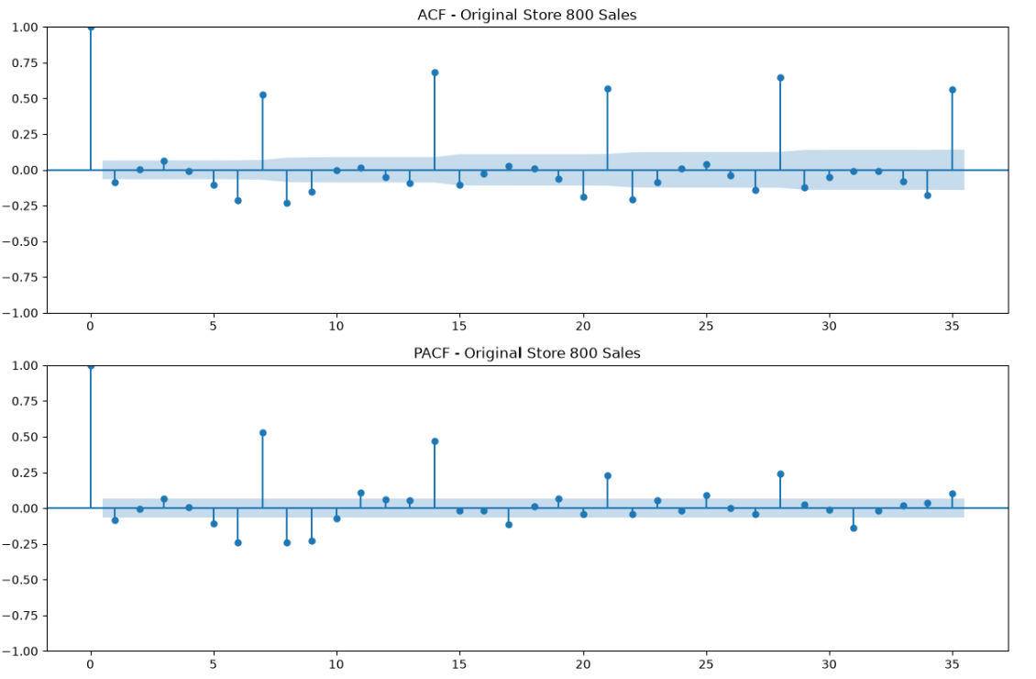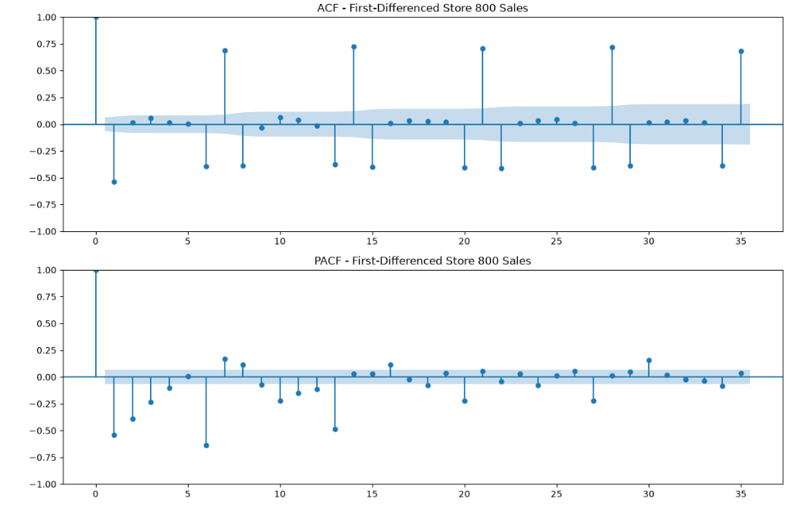
Figure 3.2.1a: Store 800 – Autocorrelation (ACF) and Partial Autocorrelation (PACF) of Daily Sales | Figure 3.2.1b: Store 800 – first differenced Autocorrelation (ACF) and Partial Autocorrelation (PACF) of Daily Sales

3.4 Baseline Forecasting Results and Interpretation
Four baseline forecasting methods: Naive, Seasonal Naive, Drift, and Moving Average were evaluated using the final 42 days of Store 800's sales data. The purpose was to establish a baseline for comparing more advanced forecasting models.
Seasonal Naive performed best among the four methods, achieving the lowest MAE of 1,004.83 and RMSE of 1,479.89. Compared with ordinary Naive, it reduced MAE by approximately 30.7% and RMSE by 25.1%. This indicates that repeating the previous week's sales pattern was more effective than relying on the last observed sales value, a moving average, or a linear trend.
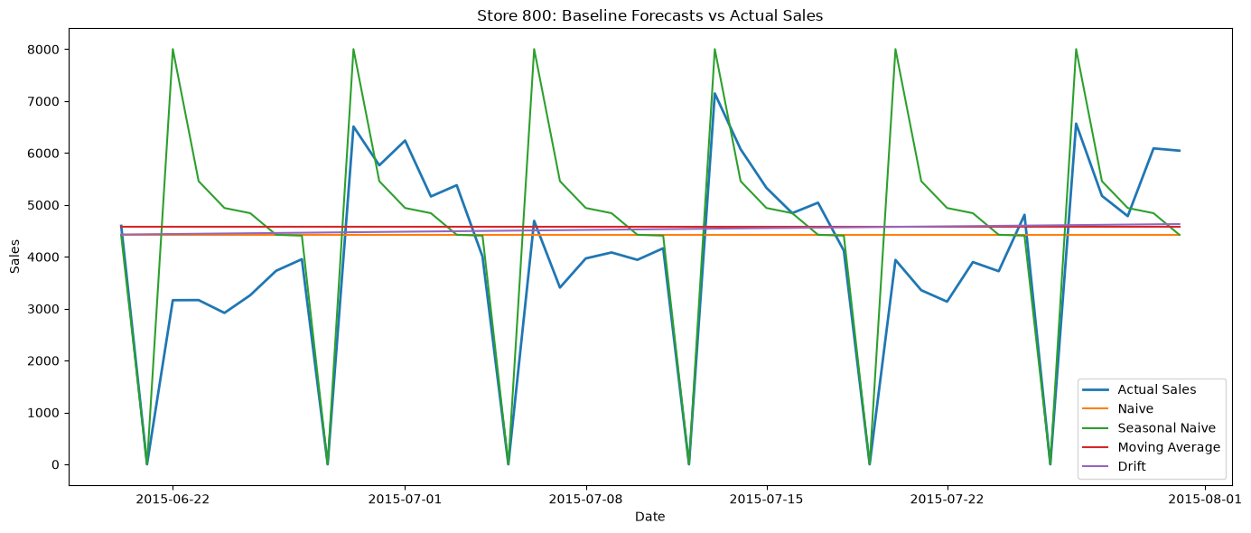
Figure 3.4.1: Store 800 – Comparison of Actual Daily Sales and Baseline Forecasting Methods (Naive, Seasonal Naive, Moving Average, and Drift).
The results highlight the importance of weekly seasonality in forecasting Store 800's sales. However, since the evaluation was based on a single 42-day test period, the findings may not be consistent across other periods. Therefore, Seasonal Naive was selected as the strongest baseline benchmark for comparison with advanced models, while rolling-origin backtesting was recommended to further assess forecasting reliability.

3.5 Model Identification and Alternative Models
After conducting the stationarity and seasonality analysis, Auto ARIMA was used to identify a suitable SARIMA model for forecasting Store 800's daily sales. The model selection process considered different combinations of autoregressive, differencing, and seasonal parameters, using the Akaike Information Criterion (AIC) to compare model fit while accounting for complexity.
Auto ARIMA selected SARIMA(5,1,0)(2,0,0)[7], with an AIC of 16,006.271. The selected model includes five non-seasonal autoregressive terms, one order of differencing, and two seasonal autoregressive terms, with a seven-day seasonal period. This allows the model to account for historical sales relationships and the weekly patterns identified during the exploratory analysis.
Other models considered included SARIMA(4,1,0)(2,0,0)[7], SARIMA(3,1,0)(2,0,0)[7], and SARIMA(2,1,0)(2,0,0)[7], with AIC values of 16,014.084, 16,024.362, and 16,028.267, respectively.
The selected model had the lowest AIC among the listed candidates, indicating a preferable fit–complexity trade-off within this candidate set. However, a lower AIC does not guarantee better forecasts on unseen data. Forecast accuracy was therefore evaluated separately on the 42-day test period and through rolling-origin backtesting.
Among the candidates listed above, SARIMA(5,1,0)(2,0,0)[7] had the lowest AIC. This criterion supported its selection for further testing, but the out-of-sample error metrics and residual diagnostics were also considered before making recommendations.
3.6 Model Training
The Store 800 dataset contained 942 daily sales observations covering January 1, 2013, to July 31, 2015. The data was arranged chronologically, with the first 900 observations used for training and the final 42 observations reserved for testing.
The selected SARIMA(5,1,0)(2,0,0)[7] model was fitted using the training data from 1 January 2013 to 19 June 2015. It includes five non-seasonal autoregressive terms, first-order differencing, and two seasonal autoregressive terms with a seven-day period.
Training the model allowed its parameters to be estimated from historical sales observations while keeping the test data separate for an unbiased evaluation of forecasting performance.
3.7 Forecast Generation
After fitting the model, sales forecasts were generated for the 42-day testing period, covering June 20, 2015, to July 31, 2015. The forecasts were aligned with the actual sales observations to assess how well the model predicted sales that were not used during training.
The forecasts were compared with the baseline methods to assess whether SARIMA offered a meaningful improvement over simpler approaches, particularly Seasonal Naive.

3.8 Comparing SARIMA with the Baseline Models
After comparing the results, we found that Seasonal Naive and SARIMA performed better than the other baseline models, although each had a different strength.
On the 42-day test period, Seasonal Naive recorded a lower MAE than SARIMA (1,004.83 versus 1,187.07), meaning its average absolute error was smaller. SARIMA recorded a lower RMSE (1,431.29 versus 1,479.89), indicating a slightly lower error under a metric that penalises larger errors more heavily.
Forecasting Model |  | MAE | RMSE
Seasonal Naive |  | 1,004.83 | 1,479.89
Naive |  | 1,449.17 | 1,976.13
Drift |  | 1,450.92 | 1,993.41
Moving Average |  | 1,471.68 | 2,019.25
SARIMA |  | 1,187.07 | 1,431.29
Table 3.8.1: Comparison of SARIMA with Baseline Models Using MAE and RMSE for Rossmann Store 800
The other baseline models performed less well. Naive recorded an MAE of 1,449.17 and an RMSE of 1,976.13, while Drift recorded 1,450.92 and 1,993.41 respectively. Moving Average had the highest errors, with an MAE of 1,471.68 and an RMSE of 2,019.25.
The 42-day test results do not identify one model as best on every metric: Seasonal Naive had the lower MAE, while SARIMA had the lower RMSE. This mixed result should be considered alongside rolling-origin backtesting and residual diagnostics.
3.9 Residual Diagnostic Analysis
Residual analysis was conducted to determine whether the SARIMA model had adequately captured the patterns in Store 800's sales data. Residuals represent the differences between actual and fitted sales values.
The residual plot showed fluctuations around zero, with some noticeable positive and negative deviations. This suggests that the model captured part of the sales behaviour, although some variations remained unexplained.
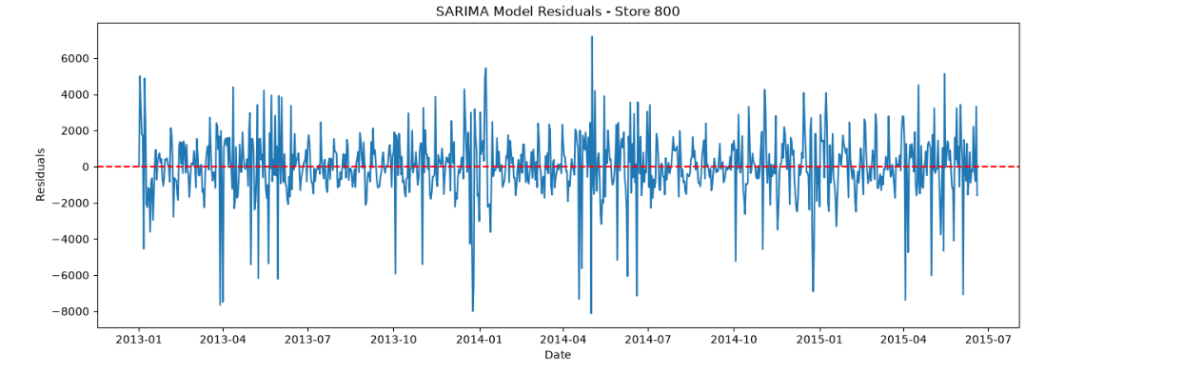
Figure 3.9.1: SARIMA Model Residuals Over Time for Rossmann Store 800 (2013–2015)
The residual ACF plot was examined to identify any remaining relationships between errors across different time periods. The Ljung-Box test was also performed at lags 7, 14, 21, and 28.
Lag | Ljung-Box Statistic | P-value
7 | 32.41 | 0.000034
14 | 116.90 | <0.001
21 | 129.11 | <0.001
28 | 157.26 | <0.001
Table 3.9.1: Ljung-Box Test Results for SARIMA Model Residual Autocorrelation – Rossmann Store 800
All reported Ljung–Box p-values were below 0.05, indicating significant residual autocorrelation at the tested lags. This suggests that the model had not captured all time-dependent patterns and that its specification could be improved.
A Q-Q plot was also used to examine the distribution of the residuals. The plot showed deviations from the expected normal distribution, indicating that the residuals were not perfectly normally distributed.
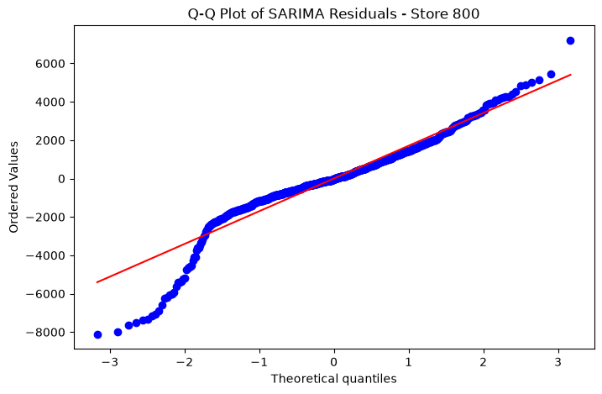
Figure 3.9.2: Q-Q Plot of SARIMA Model Residuals for Rossmann Store 800
Overall, the diagnostic results suggest that while SARIMA captured important sales patterns, further improvements may be possible.
3.10 Rolling-Origin Backtesting
Rolling-origin backtesting was used to assess performance across multiple historical periods. The procedure began with 700 observations, forecast the following seven days, and then moved forward by 28 days before repeating. This produced nine forecast windows.
Both SARIMA and Seasonal Naive were evaluated using the same forecast periods to ensure a fair comparison.
Model | Average MAE | Average RMSE
SARIMA | 1,109.17 | 1,397.67
Seasonal Naive | 1,463.90 | 1,994.23
Table 3.10.1: Average Forecasting Performance of SARIMA and Seasonal Naive Models for Rossmann Store 800

Across the nine seven-day rolling-origin windows, SARIMA achieved an average MAE of 1,109.17 and RMSE of 1,397.67. Seasonal Naive recorded an average MAE of 1,463.90 and RMSE of 1,994.23. SARIMA therefore performed better on both metrics within this backtesting setup.
These rolling-origin results favour SARIMA for the selected seven-day forecast windows. They should not be treated as directly equivalent to the original 42-day holdout results, because the forecast horizons and evaluation setups differ.
3.11 Final Six-Week Sales Forecast
After model evaluation, the selected SARIMA model was fitted using all 942 historical observations to generate a 42-day forecast for 1 August to 11 September 2015. These are historical case-study forecast dates, not a current forecast.
The initial forecast produced positive estimates for some Sundays. The historical data showed zero sales on all 134 recorded Sundays, consistent with the store's closure pattern.
As a post-processing business rule, Sunday forecasts were set to zero to reflect the known closure pattern. This adjustment was applied after the model generated its forecasts; it was not learned automatically by SARIMA. The reported accuracy metrics should not be assumed to reflect this adjustment unless they are recalculated using the adjusted predictions.
The resulting adjusted forecast illustrates how a statistical model can be combined with known operating rules. It could inform inventory and staffing discussions, but the forecast should be validated further before being used operationally.
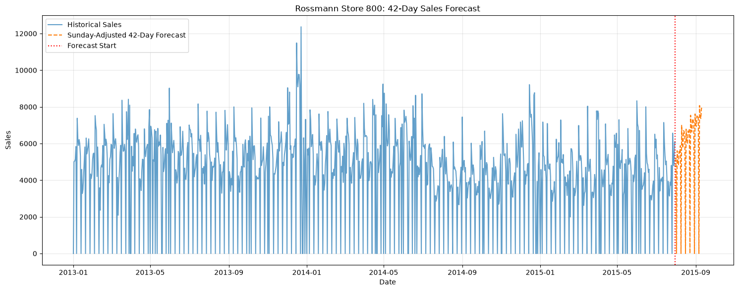
Figure 3.11.1: Historical Daily Sales and 42-Day Sunday-Adjusted Sales Forecast for Rossmann Store 800

4.0 Recommendations and Conclusion
4.1. Could Poor Forecasting Be Costing Rossmann Money?
Poor forecasts can affect stock ordering and staff scheduling. Overestimating sales may contribute to excess stock or unnecessary staffing, while underestimating sales may contribute to stock shortages or insufficient staffing during busy periods.
Our results show that forecast errors remain. On the original test period, SARIMA had an MAE of about 1,187 sales units per day, compared with 1,005 for Seasonal Naive.
The actual financial impact cannot be calculated from this analysis because information on stock costs, profit margins, staffing costs, and lost sales was not available. The project identifies potential business implications but does not quantify financial losses or savings.
4.2 Recommendation
We do not recommend adopting SARIMA across all Rossmann stores on the basis of this single-store analysis. SARIMA performed better on both metrics in the selected rolling-origin backtests, but Seasonal Naive had a lower MAE on the original 42-day test. Residual diagnostics also indicate that SARIMA could be improved.
We recommend evaluating both models across additional stores and different time periods. Future model development should also account for promotions, holidays, and store-opening status where reliable features are available.
If Seasonal Naive provides sufficiently accurate forecasts, it may be preferable because it is simpler to implement and maintain. SARIMA should be preferred only if testing demonstrates a clear and repeatable benefit for the intended forecast horizon.
4.3 Conclusion
Store 800's sales displayed a weekly pattern, and average sales differed across promotion and school-holiday categories. SARIMA performed better than Seasonal Naive in the selected rolling-origin backtests, but it did not outperform Seasonal Naive on every metric in the original 42-day test.
The analysis demonstrates how sales forecasting could support inventory and staffing decisions, but further testing is needed before selecting a method for wider use. Financial data would also be required to estimate any potential cost savings or losses.

